## A Novel Deep Learning Based Oral Cancer Disease Detection: A Diversified Image Analysis

## A PROJECT REPORT

***Submitted by***

## ANUSTHA PRIYA SAHU – 2101020001

## MANAS KUMAR– 2101020020

## KHUSHI SAXENA– 2101020092

**HIMANSHU MONDAL – 21010200106**

***Towards completion of major project Stage-I (7th semester)***

***of***

# BACHELOR OF TECHNOLOGY

***in***

## COMPUTER SCIENCE & ENGINEERING

**Department of Computer Science & Engineering**

## C.V. RAMAN GLOBAL UNIVERSITY BHUBANESWAR-ODISHA-752054

**NOVEMBER 2024**

APPENDIX 2

**C.V. RAMAN GLOBAL UNIVERSITY BHUBANESWAR-ODISHA-752054**

# CERTIFICATE OF APPROVAL

This is to certify that we have examined the project entitled **" A Novel Deep Learning-Based Oral Cancer Disease Detection: A Diversified Image Analysis"** submitted by **ANUSTHA PRIYA SAHU, Registration No.-2101020001, MANAS KUMAR, Registration No.- 2101020020, KHUSHI SAXENA, Registration No.- 2101020096, HIMANSHU MONDAL-2101020106**

CGU-Odisha, Bhubaneswar. We here by accord our approval of it as a major project work carried out and presented in a manner required for its acceptance towards completion of major project stage-I (7th Semester) of **Bachelor Degree of Computer Science & Engineering** for which it has been submitted. This approval does not necessarily endorse or accept every statement made, opinion expressed or conclusions drawn as recorded in this major project, it only signifies the acceptance of the major project for the purpose it has been submitted.

**SUPERVISOR HEAD OF THE DEPARTMENT**



##### **C.V. RAMAN GLOBAL UNIVERSITY**

##### **BHUBANESWAR-ODISHA-752054**

**BONAFIDE CERTIFICATE**

Certified that this project report **"** A Novel Deep Learning Based Oral Cancer Disease Detection: A Diversified Image **"** is a 7th Semester bonafide work submitted by **ANUSTHA PRIYA SAHU, Registration No.-2101020001, MANAS KUMAR, Registration No.- 2101020020, KHUSHI SAXENA, Registration No.- 2101020096, HIMANSHU MONDAL-2101020106** CGU-Odisha, Bhubaneswar who carried out the project under my supervision.

Dr. Monalisha Mishra

**HEAD OF THE DEPARTMENT** Department of Computer Science & Engineering

Dr. Ram Chandra Barik

**SUPERVISOR**

Associate Professor, Department of Computer Science & Engineering

# ACKNOWLEDGEMENT

We would like to articulate our deep gratitude to our project guide **Dr. Ram Chandra Barik, Assistant Professor, Computer Science Department,** who has always been source of motivation and firm support for carrying out the project.

We would also like to convey our sincerest gratitude and indebtedness to all other faculty members and staff of Department of Computer Science Engineering, who bestowed their great effort and guidance at appropriate times without it would have been very difficult on our project work.

An assemblage of this nature could never have been attempted with our reference to and inspiration from the works of others whose details are mentioned in the references section. We acknowledge our indebtedness to all of them. Further, we would like to express our feeling towards our parents and God who directly or indirectly encouraged and motivated us during Assertion.

|  |  |
| --- | --- |
| **STUDENT’S NAME** | **REG. NO** |
| **ANUSTHA PRIYA SAHU** | **2101020001** |
| **MANAS KUMAR** | **2101020020** |
| **KHUSHI SAXENA** | **2101020092** |
| **HIMANSHU MONDAL** | **2101020106** |

APPENDIX 3

# TABLE OF CONTENTS

|  |  |  |
| --- | --- | --- |
|  | **TITLE** | **PAGE NO.** |
|  | **ABSTRACT** | v |
|  | **LIST OF TABLES** | vi |
|  | **LIST OF FIGURES** | vi |
|  | **LIST OF SYMBOLS** | vi |
| **1** | **INTRODUCTION** | 1 |
| 1.1 | Oral Cancer | 1 |
| 1.2 | Detection model | 1 |
| 1.3 | Problem statement | 2 |
| 1.4 | Solution | 2 |
| **2** | **LITERATURE SURVEY** | 3 |
| **3** | **METHODOLOGY** | 5 |
| 3.1 | Dataset collection | 5 |
| 3.1.1 | Description of data set | 5 |
| 3.2 | Proposed model | 6 |
| 3.2.1 | Resnet-50 | 6 |
| 3.2.1.1 | Resnet architecture | 6 |
| 3.2.1.2 | Block diagram | 9 |
| 3.3 | Stages of proposed model | 10 |
| 3.3.1 | Image augmentation | 10 |
| 3.3.2 | Implementation of model | 11 |
| 3.3.2.1 | Load and preprocess image: | 11 |
| 3.3.2.2 | Prediction using resnet-50 | 11 |
| **4** | **RESULTS** | 12 |
| **5** | **CONCLUSION** | 13 |
| **6** | **REFERENCES** | 14 |

**ABSTRACT**

Oral cancer is a life-threatening condition that significantly impacts global health, accounting for substantial morbidity and mortality rates. Early detection of oral cancer is crucial as it greatly improves treatment outcomes, reduces the need for invasive procedures, and enhances patient survival rates. When diagnosed at an early stage, oral cancer can often be treated successfully with a combination of surgery, radiation, and chemotherapy. However, the lack of symptoms in the initial stages often leads to late diagnosis, which drastically reduces survival chances and increases treatment complexity. Early detection also reduces healthcare costs by preventing the progression of the disease, thereby decreasing the burden on both patients and healthcare systems. Advances in technology, particularly in deep learning and image analysis, now offer promising solutions for automating and enhancing the accuracy of oral cancer detection, ensuring timely intervention and improved quality of life for patients.

This project introduces a novel deep learning-based approach for detecting oral cancer through diversified image analysis, leveraging both microscopic and macroscopic datasets. By utilizing the ResNet-50 architecture, the model effectively addresses challenges in analyzing high-dimensional image data, enabling accurate and efficient classification of cancerous and non-cancerous samples. The microscopic dataset comprises histopathological images, while the macroscopic dataset includes clinical images of oral lesions. Data augmentation techniques, including rotations and flips, were applied to enhance model robustness. The outcome of your model for would be a robust and efficient classification system capable of identifying cancerous and non-cancerous images from two datasets—microscopic (histopathological) and macroscopic (clinical oral lesions).

# LIST OF FIGURES

TABLE 1: Literature Review TABLE 2: Result table

# LIST OF FIGURES

FIG 1: Oral Cancer dataset. FIG 2: Normal Microscopic images

FIG 3: Cancerous microscopic images

FIG 4: Normal Microscopic Images

FIG 5: Normal Microscopic Images

FIG 6: Architecture of ResNET-50

FIG 7: Image augmentation

# LIST OF SYMBOLS

**1**.**All the Accuracy**: Represents the percentage of correctly classified lesions. It is calculated using the formula:

Accuracy= $\frac{TP+TN}{n}$

TP: True Positives (correctly classified malignant lesions)

TN: True Negatives (correctly classified benign lesions)

n: Total number of samples

**2.Specificity:**

Specificity indicates the percentage of benign lesions correctly identified by the

model.

The formula is: $\frac{TN}{TN+FP}$

**FP**: False Positives (benign lesions incorrectly classified as malignant)

​3. **Sensitivity (or Recall):**

Sensitivity reflects the percentage of malignant lesions correctly detected by the model. It is computed as:

$$\frac{TP}{TP+FN}$$

FN: False Negatives (malignant lesions incorrectly classified as

benign)

**ROC and AUC Curve**:

The ROC (Receiver Operating Characteristic) curve plots Sensitivity against

1−Specificity, showing the trade-off between true positive rate and false positive rate.

The AUC (Area Under the Curve) measures the total area under the ROC curve, with an ideal value of 1.0, indicating perfect separation of benign and malignant classes.

# INTRODUCTION

## ORAL CANCER

## In the rapidly advancing field of healthcare, the early diagnosis and treatment of diseases are crucial for improving patient outcomes and reducing mortality rates. Oral cancer, a serious global health issue, presents significant challenges due to its high prevalence and the severe consequences of late detection. Addressing this growing concern, our research focuses on an innovative approach that leverages deep learning techniques to enhance the detection and classification of oral cancer through advanced image analysis.

## Conventional methods for detecting oral cancer often depend on visual assessments and biopsies, which are not only invasive but also time-intensive and prone to variability among practitioners. In contrast, our solution utilizes state-of-the-art machine learning algorithms, specifically transfer learning with ResNet-50, to process diverse datasets of oral images. This approach enables efficient and accurate identification of cancerous lesions, ensuring a faster diagnostic process and enabling timely medical interventions. By automating the detection process with a high degree of reliability, this system aims to alleviate the workload of healthcare professionals while significantly improving the prospects for early detection and better patient care.

## DETECTION MODEL

This project delves into the intricacies of our machine learning model, focusing on its design and application in detecting oral cancer from a diverse set of clinical images. The primary aim is to provide an in-depth understanding of how this state-of-the-art technology can revolutionize early diagnosis and treatment planning for oral cancer, thereby improving patient outcomes.

The incorporation of a sophisticated and advanced CNN architecture, such as ResNet-50, ensures optimal performance in image analysis by extracting intricate features and distinguishing between benign and malignant lesions with precision. This approach not only enhances the diagnostic accuracy but also supports clinicians in early intervention, enabling timely and effective treatment of oral cancer.

## PROBLEM STATEMENT

The detection of oral cancer poses several challenges:

1. **Diversity in Image Data**: Existing systems often focus on either microscopic or macroscopic images, limiting their ability to generalize across datasets with varied features.
2. **Manual Diagnostics**: Traditional methods are subjective and reliant on specialist expertise, leading to inconsistent results and delayed diagnoses.
3. **Lack of Automation**: Automated tools for oral cancer detection that are both accurate and efficient remain scarce, especially for diverse imaging conditions.

These limitations necessitate the development of an advanced solution capable of handling diverse datasets while maintaining high accuracy and scalability.

## SOLUTION

This project proposes a novel deep learning-based solution for oral cancer detection by leveraging the ResNet-50 architecture and transfer learning. The methodology integrates:

* **Diversified Datasets**: Combines microscopic and macroscopic images to improve robustness and generalizability.
* **Data Augmentation**: Enhances model performance by simulating real-world imaging conditions through transformations like rotations, flips, and brightness adjustments.
* **Transfer Learning with ResNet-50**: Utilizes pre-trained models fine-tuned on the project-specific dataset to accelerate training and improve accuracy.

The proposed model aims to achieve high training and testing accuracy, providing a scalable and automated diagnostic tool that can reduce reliance on invasive procedures and support early detection, ultimately improving patient outcomes.

# LITERATURE SURVEY

|  |  |  |  |  |  |  |
| --- | --- | --- | --- | --- | --- | --- |
| SL No | Authors and Publication Details | Indexing & Publisher | Journal | Tools/Methods Used | Objectives | Limitations |
| 1 | Xinyi Zhang and Frederico O. Gleber-Netto (January 2023) | SCIE, WILEY | Cancer Medicine | CNN-based histology image analysis | To accelerate the discovery of oral leukoplakia (OL) cancer progression risk models and reduce oral cancer morbidity and mortality. | Large interobserver variability and weakly prognostic nature of current OL progression risk assessment methods. |
| 2 | Pandia Rajan Jeyaraj & Edward Rajan Samuel Nadar (January 2019) | SCIE, SPRINGER | Journal of Cancer Research and Clinical Oncology | Deep learning for automated oral cancer detection, comparison with SVM and DBM | To develop a deep learning algorithm for computer-assisted early oral cancer detection, achieving high accuracy, sensitivity, and specificity. | Challenges in designing accurate classifiers and processing feature maps with less variation. |
| 3 | Aubreville, M., et al. (September 2017) | SCIE, WILEY | IET Image Processing | Deep learning framework for real-time classification | To improve classification accuracy of oral cavity images using a deep learning framework. | Small dataset affecting the generalizability of the model. |
| 4 | Natheer Al-Rawi, Afrah Sultan, et al. (August 2022) | SCIE, ELSEVIER | International Dental Journal | Supervised and deep learning methods, database analysis using PubMed, Scopus, EBSCO, and OVID | To assess AI's role in early detection of oral cancer (OC), its diagnostic accuracy, and impact on survival rates. | Variability in results, no consensus on the best AI method, and findings limited to specific demographics and imaging techniques. |
| 5 | Kathiravan Srinivasan (April 2023) | SCIE, MDPI | Diagnostics | Telecytology, ANN, and ML/DL models (DBN, RF, ANN, DNN, KNN) | To review AI techniques for oral cancer detection and treatment, evaluating performance across different ML and DL models. | Poor sensitivity (~18%) in recognizing lesions and traditional cytology limitations in identifying potentially malignant lesions. |
| 6 | Kayla Caughlin, et al. (October 2022) | SCIE, IEEE | Journal of Biomedical and Health Informatics | Domain adaptation module, gradient reversal layer, and domain classifier | To enhance performance using small datasets and achieve domain invariance in medical imaging data. | Small dataset size due to privacy issues and domain shifts between imaging centers hindering direct data combination. |

# METHODOLOGY

* 1. **DATASET COLLECTION**

## DESCRIPTION OF DATA SET

The dataset consists of two types of image data: **Microscopic** and **Macroscopic**. Each dataset is divided into three subsets for training, validation, and testing. The different classes of each dataset is represented in figures 1,2,3 and 4. The entire dataset adheres to a structured organization, and it has been strategically divided into training and validation sets, maintaining an 80/20 ratio, to facilitate effective model training and assessment.

#### **Microscopic Dataset**

* **Total Images:** 5192
  + **Normal:** 2494
  + **Oral Squamous Cell Carcinoma (OSCC):** 2698
* **Dataset Splits:**
  + **Training:**
    - Normal: 1775
    - OSCC: 1859
  + **Validation:**
    - Normal: 359
    - OSCC: 420
  + **Testing:**
    - Normal: 360
    - OSCC: 419

#### **Macroscopic Dataset**

* **Total Images:** 750
  + **Normal:** 250
  + **Oral Squamous Cell Carcinoma (OSCC):** 500
* **Dataset Splits:**
  + **Training:**
    - Normal: 166
    - OSCC: 359
  + **Validation:**
    - Normal: 75
    - OSCC: 37
  + **Testing:**
    - Normal: 47
    - OSCC: 66

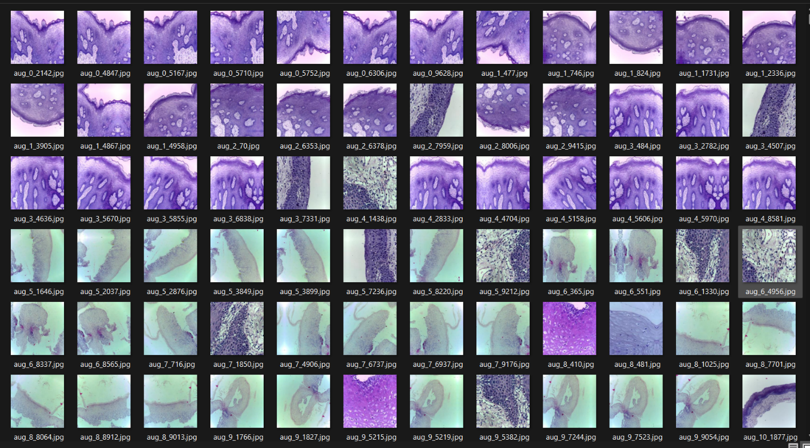

Fig 1.normal microscopic images

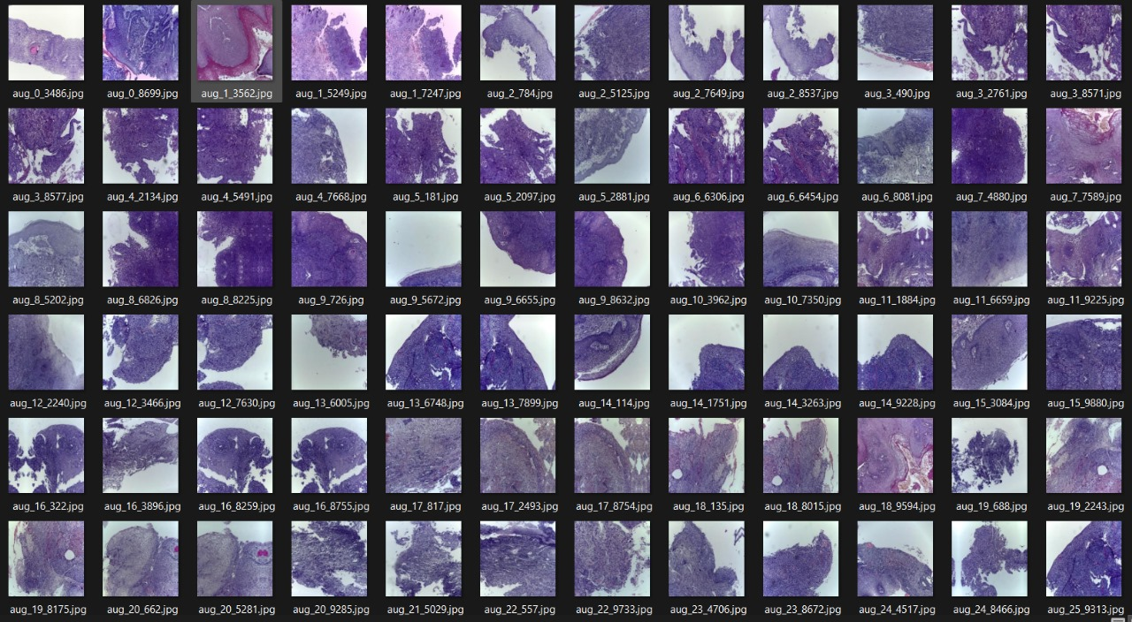

Fig 2. Cancerous microscopic images

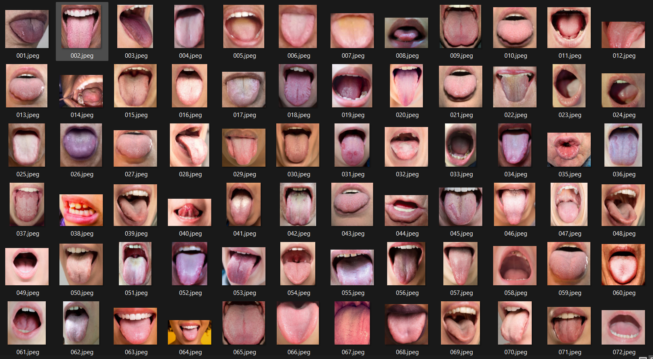

Fig 3. Normal macroscopic images

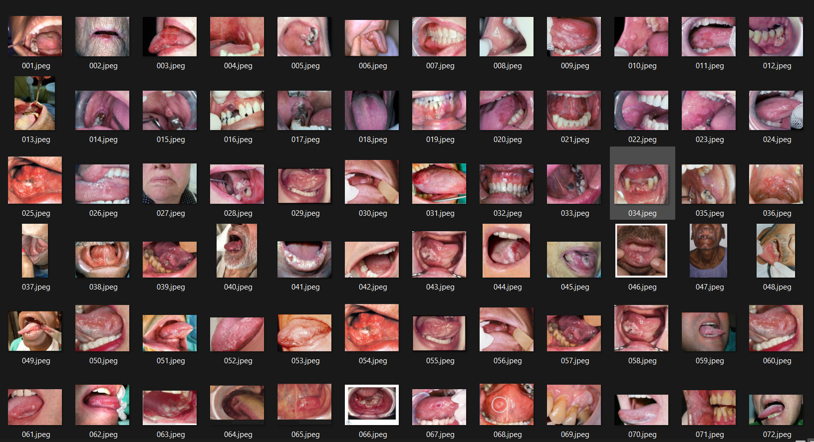

Fig 4. Normal macroscopic images

## PROPOSED MODEL

* + 1. **ResNET-50: An Overview**

ResNet-50 is a deep neural network architecture from the ResNet (Residual Network) family, which represents a significant advancement in convolutional neural networks (CNNs). Developed by Microsoft Research, ResNet was first introduced in the research paper titled "Deep Residual Learning for Image Recognition". ResNet-50, in particular, is widely recognized for its innovative use of residual blocks, which overcome challenges like the vanishing gradient problem and allow for the effective training of very deep networks.

### **Key Features**

* ResNet-50 is a **50-layer deep neural network**, with the number "50" referring to the total trainable weight layers in the model.
* Its depth is achieved through **residual blocks**, a core feature of the ResNet family. Rather than learning the output directly, residual blocks focus on learning the residual — the difference between the input and the expected output — making the network more efficient and easier to train.

## ResNet Architecture:

The ResNet-50 architecture, which forms the backbone of the proposed model for oral cancer detection, has been selected due to its ability to handle complex image classification tasks with high accuracy. This model is specifically designed to improve the early detection of oral potentially malignant disorders (OPMDs) and squamous cell carcinoma (SCC) of the tongue, leveraging the residual learning capabilities of ResNet-50.

The architecture of ResNet-50 includes several fundamental components, such as convolutional layers, pooling layers, fully connected layers (accompanied by activation functions), and residual blocks. These elements work together to build a highly effective model for tasks like image recognition.  
The following are key building blocks of ResNet-50:

**Convolutional Layers**

* The architecture typically starts with a convolutional layer containing a large number of filters (e.g., 32 filters).
* These layers apply convolution operations using filters, strides, and padding to extract features from the input data effectively.

**Input Layer:**

The input layer is configured to process images of 224 × 224 × 3, which corresponds to the dimensions of clinical images of tongue lesions. This allows the model to handle real-world images effectively.

**Residual Blocks**

Residual blocks are central to the architecture. Instead of learning a direct mapping, they learn a residual connection, which simplifies the training process and allows deeper networks to perform better.

Global max pooling and fully connected layers are often incorporated near the end of the architecture to process extracted features and produce predictions.

**Max-Pooling Layer:**

* This operation selects the maximum value from each region within a specified pool size, discarding all other values.
* Max-pooling is commonly used to downsample feature maps, reducing spatial dimensions while retaining key features. This helps capture hierarchical patterns and enhances computational efficiency.

**Activation Function:**

1. **Intermediate Layer Activation:**
   * **In the Dense layer with 256 neurons:**

**Dense(256, activation='relu')**

* + - **Activation Function: ReLU (Rectified Linear Unit)**
    - **Purpose: Introduces non-linearity to the model, ensuring it can learn complex patterns.**

1. **Output Layer Activation:**
   * **In the Dense layer for the output:**

**Dense(class_count, activation='softmax')**

* + - **Activation Function: Softmax**
    - **Purpose: Used for multi-class classification. It converts the outputs into probabilities, with the sum of probabilities for all classes equal to 1.**
* Activation functions are essential in Convolutional Neural Networks (CNNs) as they introduce non-linearity, enabling the network to learn complex relationships between inputs and outputs.
* In this model, we utilize the **ReLU** and **Softmax** activation functions.

**ReLU Activation Function:**

* **Formula**: f(x)=max(0,x)
* ReLU (Rectified Linear Unit) is one of the most popular activation functions used in residual networks.
* It plays a vital role in addressing the vanishing gradient problem.
* FIG 5 illustrates the graph of ReLU, and FIG 6 shows its mathematical derivation.

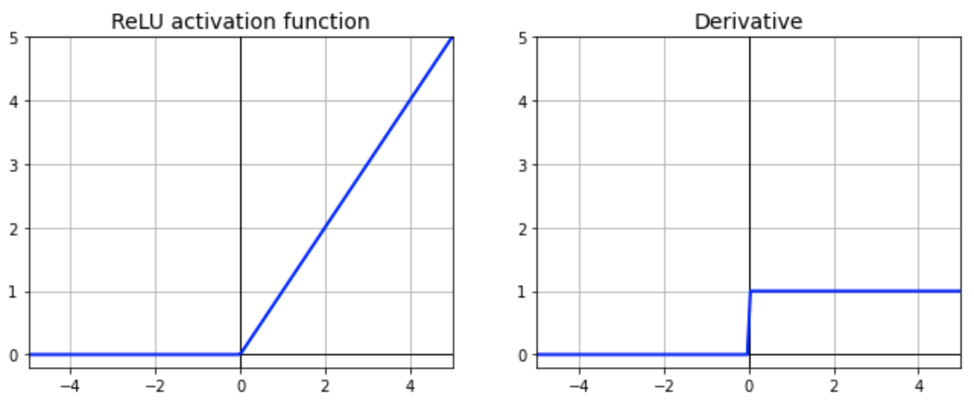Fig.5 Graph of ReLU Fig.6 Derivative of ReLU

**Softmax Activation Function**

1. **Purpose**: Converts raw scores (logits) into a probability distribution over multiple classes.
2. **Fig 7 gives the formula for softmax activation function**

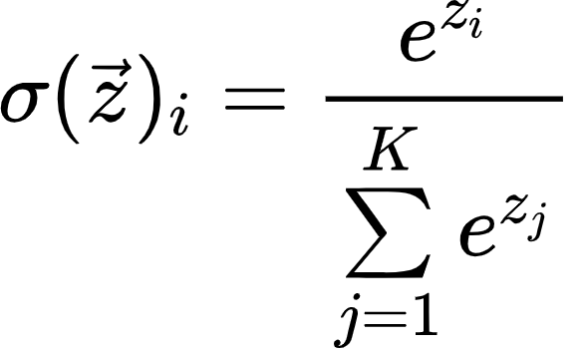

Fig.7 Formula for SoftMax Activation Function

* + The denominator is the sum of exponentials of all logits.

1. **Range**: Outputs probabilities between 0 and 1, summing to 1.
2. **Key Features**:
   * **Normalization**: Ensures the output is a valid probability distribution.
   * **Exponentiation**: Amplifies higher scores, suppressing lower ones.
3. **Use Case**: Commonly used in the output layer of neural networks for multi-class classification problems.
4. **Example**: For logits [2.0,1.0,0.1][2.0, 1.0, 0.1][2.0,1.0,0.1], Softmax converts them into probabilities [0.57,0.23,0.10][0.57, 0.23, 0.10][0.57,0.23,0.10].

**Optimizer:**

• The choice of optimizer is a crucial decision during the training process.

• **Optimizer**

* The optimizer used is:

Adamax(learning_rate=0.001)

* + Optimizer: Adamax
  + Learning Rate: 0.001
  + Purpose: Adamax is a variant of the Adam optimizer based on the infinity norm, and it is particularly useful when dealing with sparse gradients.

**Adam Optimizer:**

The Adam optimizer merges the ideas of momentum and RMSProp. It adjusts the learning rate for each parameter individually, making it highly effective across various tasks. Figure 8 illustrates the performance curve of the Adam optimizer.

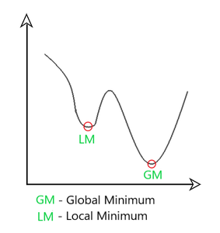

Fig.8: Performance Curve of Adam Optimizer

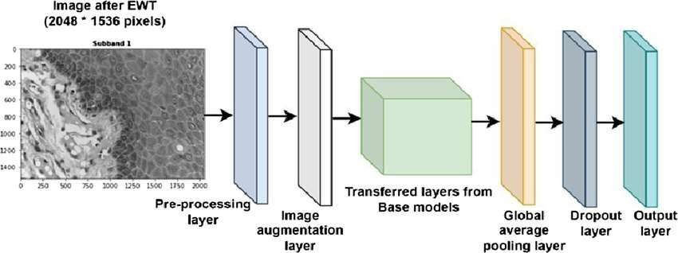

**3.2.1.2 BLOCK DIAGRAM**

**FIG 9: Architecture of ResNET-50**

# 3.3. STAGES OF PROPOSED MODEL

# THE PROPOSED MODEL FOR DISEASE DETECTION COMPRISES TWO PRIMARY STAGES:

1.Image Augmentation

2.Model Implementation

# STAGES OF PROPOSED MODEL

Proposed The proposed model for disease detection comprises two primary stages:

1.Image Augmentation

2.Model Implementation:

# IMAGE AUGMENTATION

In the context of oral cancer disease detection using both microscopic and macroscopic datasets, image augmentation is used to simulate various real-world conditions, such as different camera angles and orientations of the tissue samples. This is achieved through techniques like horizontal flipping, which helps simulate variations in how the images might be captured in practice. Although the augmentation in the current setup is limited to horizontal flips, this method introduces diversity in the training data, enabling the model to learn more robust features and making it less sensitive to the orientation of the tissue images.

By exposing the model to multiple augmented versions of the same images, the model is able to generalize better, focusing on key features related to oral cancer detection rather than memorizing specific image instances. This approach significantly reduces the risk of overfitting and enhances the model's ability to accurately classify both microscopic and macroscopic images, ensuring better performance on real-world datasets.

**Techniques Employed**

Rotations:

Images are rotated by 90°, 180°, and 270° to simulate different angles of tongue positioning during imaging.

**Symmetry Transformations:**

Includes horizontal and vertical flips to mimic different views of oral lesions.

**Scaling and Cropping:**

Random zoom-in and zoom-out operations.

Highlights localized features of oral lesions while retaining the global structure.

**Brightness and Contrast Adjustments:**

Alters image intensity to replicate lighting variations typically encountered in clinical settings.

**Purpose and Benefits**

Prevent Overfitting:

By exposing the model to diverse augmented data, it avoids memorizing specific instances and generalizes better to unseen clinical images.

Enhance Model Robustness:

Augmentation helps the model perform reliably across different imaging scenarios, such as varying patient positioning and camera settings.

Focus on Key Features:

Ensures the model identifies critical patterns in the lesions, such as texture and color variations, rather than irrelevant background details.

Illustration of Image Augmentation

The augmentation process creates multiple versions of an image, capturing diverse real-world scenarios. This ensures the model's robustness and adaptability when analyzing clinical images of oral lesions.

# IMPLEMENTATION OF MODEL

The feature extraction operations on the input image matrix are handled by the pre-trained ResNet50 model, which is utilized for both microscopic and macroscopic datasets in the oral cancer detection task.

#### 3.3.2.1 Load and Preprocess Image

The first step in preparing the image involves loading it from the specified file path and resizing it to a consistent dimension of 224x224 pixels. This dimension is selected to align with the input requirements of the ResNet50 model, ensuring compatibility with both microscopic and macroscopic images.

Subsequently, the image is converted into a NumPy array, a necessary step to transform the image into a numerical format that can be processed efficiently by the neural network. This conversion ensures seamless integration with the model's input requirements.

The final preprocessing step involves expanding the image's dimensions from 3D (height, width, channels) to 4D. This transformation is essential because neural networks process input in batches, even if only a single image is being evaluated. The additional dimension ensures the image is appropriately handled in batch processing, facilitating smooth interaction with the ResNet50 model.

#### 3.3.2.2 Prediction using ResNet50

Once preprocessed, the image from either the microscopic or macroscopic dataset is passed through the pre-trained ResNet50 model. The model generates a probability distribution across the various possible classes, reflecting its confidence in each classification.

The predicted class is determined by identifying the index of the highest probability using np.argmax. This index corresponds to the class that the model predicts with the highest likelihood, and this prediction is used to label the image, whether it is from the microscopic or macroscopic dataset.

.

# RESULT:

### Microscopic Dataset

|  |  |
| --- | --- |
| **Parameter** | **Value** |
| Model Name | ResNet50 |
| Number of Images | 5192 |
| Epochs | 20 |
| Loss | 3.6146 |
| Train Accuracy | 0.9081 (90.81%) |
| Test Accuracy | 0.9435 (94.35%) |
|  |  |

## TABLE 1: Result Table for microscopic dataset

**Macroscopic Dataset**

|  |  |
| --- | --- |
| Parameter | Value |
| Model Name | ResNet50 |
| Number of Images | 750 |
| Epochs | 20 |
| Loss | 2.2497 |
| Train Accuracy | 0.9962 (99.62%) |
| Test Accuracy | 0.9375 (93.7%) |

## TABLE 2: Result Table for macroscopic dataset

* Table 1 describe the parameters and its values for the microscopic dataset and found the train accuracy – 90%, while testing accuracy – 94%.
* Table 2 describe the parameters and its values for the macroscopic dataset and found the train accuracy – 99%, while testing accuracy – 93%.

1. Plagarism Report

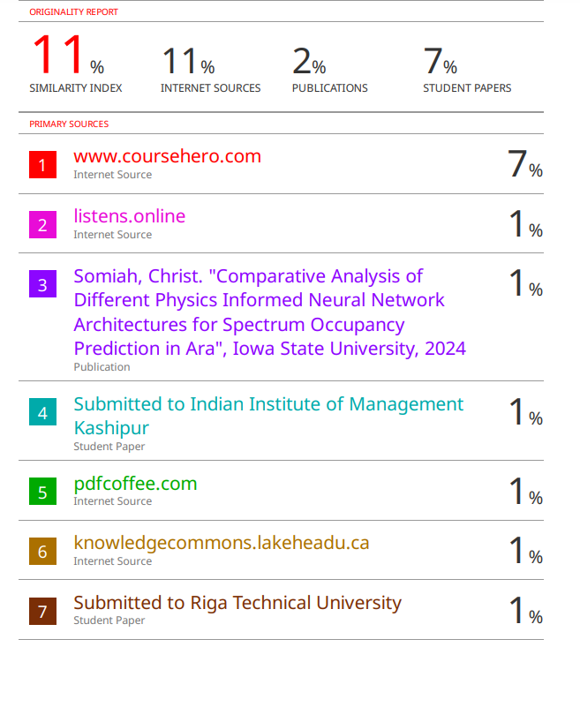

# CONCLUSION

The ResNet50-based model has demonstrated remarkable performance in oral cancer detection, achieving high accuracy across both microscopic and macroscopic datasets. This model's ability to effectively classify clinical images from diverse sources emphasizes its potential as a reliable tool for early diagnosis, significantly improving the management of oral cancer.

Its scalability and adaptability position the model as an ideal solution for real-time clinical use, particularly in resource-limited settings or underserved regions. By integrating with telemedicine platforms, the model can expand access to critical diagnostic services, reducing the need for specialized professionals and lowering diagnostic costs. This automation can enable primary healthcare providers to identify early signs of oral cancer, ensuring timely intervention and referrals for specialized care.

The ResNet50 model was trained on two distinct datasets: the microscopic dataset consisting of 5,192 images and the macroscopic dataset with 750 images. Both datasets were processed over 20 epochs, showcasing the model's adaptability across different types of data. For the microscopic dataset, the model achieved a training accuracy of 90.81% and demonstrated excellent generalization with a test accuracy of 94.35%. In contrast, the macroscopic dataset saw an even higher training accuracy of 99.62%, with a test accuracy of 93.7%, highlighting the model's strong learning capabilities. The loss for the microscopic dataset was 3.6146, while for the macroscopic dataset, it was 2.2497. These results underline the effectiveness of the ResNet50 model in oral cancer detection, demonstrating its robustness and potential for accurate image classification across diverse clinical datasets.

With further optimization and refinements, the ResNet50-based model has the potential to revolutionize oral cancer detection, contributing to higher survival rates and a reduction in the global burden of the disease. By bridging gaps in accessibility, accuracy, and affordability, this model offers a transformative solution to enhance public health outcomes and improve early detection for oral cancer patients worldwide.

# REFERENCES

1. Deep learning-based pathology image analysis predicts cancer progression risk in patients with oral leukoplakia:

• Speight PM, Khurram SA, Kujan O : Oral potentially malignant disorders: risk of progression to malignancy. Oral Surg Oral Med Oral Pathol Oral Radiol. 2018;125(6):612- 627

2. Computer-assisted medical image classification for early diagnosis of oral cancer employing deep learning algorithm:

• Hijazi H, Chan C (2012) : A classification framework applied to cancer gene expression profiles. J Healthc Eng 4(4):255–284

3. Automatic classification of cancerous tissue in laser endomicroscopy images of the oral cavity using deep learning:

• Aubreville, M., et al.: Automatic classification of cancerous tissue in laserendomicroscopy images of the oral cavity using deep learning. Sci. Rep. 7(1), 11979 (2017)

4. The Effectiveness of Artificial Intelligence in Detection of Oral Cancer

• BIlhan,PGuneri, P. Wilder-Smith : The contribution of artificial intelligence to reducing the diagnostic delay in oral cancer. Oral Oncol, 116 (2021), Article 105254

5. A Current Review of Machine Learning and Deep Learning Models in Oral Cancer Diagnosis: Recent Technologies, Open Challenges, and Future Research Directions

• Das, N.; Hussain, E.; Mahanta, L.B : Automated classification of cells into multiple classes in epithelial tissue of oral squamous cell carcinoma using transfer learning and convolutional neural network. Neural Networks 2020, 128, 47–60

6. Aligning Small Datasets Using Domain Adversarial Learning: Applications in Automated in Vivo Oral Cancer Diagnosis

• Vasanthakumari P et al. , “Classification of skin-cancer lesions based on fluorescence lifetime imaging,” Proc. SPIE vol. 11317, w2020, pp. 245–253